# Mini-Project Report

[](tpc.gjuonline.ac.in)

S

Project Report on Training & Placement Cell Website

Submitted By

**Rahul (15014027)**



Under Supervision

**Mr Partap Singh Malik**

(Director Training & PLacement Cell)

# Acknowledgment

I have taken efforts in this project. However, it would not have been possible without the kind support and help of many individuals and organizations. I would like to extend my sincere thanks to all of them. I am highly indebted to Mr. Partap Singh Malik(Director, Training & Placement Cell), and our respected Seniors Balvinder Singh, Kartik Goyal for their guidance and constant supervision as well as for providing necessary information regarding the project & also for their support in completing the project. I would like to express my gratitude towards my parents & member of Training & Placement Cell earlier Web Team Members, for their kind co-operation and encouragement which help me in the completion of this project.

My thanks and appreciations also go to my colleague in developing the project and people who have willingly helped me out with their abilities.

# Declaration

I, **Rahul Chanana, hereby declare that the report of the project entitled “[Training & Placement Cell Website](tpc.gjuonline.ac.in)” has not been presented as a part of any other academic work to get my degree or certificate except in Guru Jambheshwar University of Science & Technology, Hisar for the fulfillment of the requirements for the degree of Bachelor of Technology (COMPUTER SCIENCE).**

**Rahul Chanana**

# Table of Contents

Mini-Project Report 1

Acknowledgment 2

Declaration 3

Table of Contents 4

1.Introduction 5

2.Tools Description 7

3.Description about various Languages 8

3.Methodology and Coding from various files 15

4.Testing Samples 32

# 1.Introduction

**1.1 OverView:**

This report discusses the result of the work done in development of the website of [Training & Placement Cell](tpc.gjuonline.ac.in), Guru Jambheshwar University of Science & Technology, for facilitating & providing a platform to the Industry Professionals and Student to have fruitful interaction.

**1.2 Background and Motivation:**

During the past few years, Training & Placement Cell (Guru Jambheshwar University of Science & Technology, Hisar) have no way to interact with industry professionals and students of the University except Newspapers and Mailing Services, that either leads to miscommunication or non-fruitful result.

With the goal of providing solutions to the above problem, the students of Information Technology of the Batch (2013-17) and our respected Seniors Mr Balvinder Singh, Mr Pawan Yadav, Mr Sukhvinder, & Mr Vijay developed a website under the guidance of Mr HC Garg It was based on the WordPress, which is a popular open source software which is used to create a beautiful website, blog, or app, with less Coding and easy to handle Interface, without sacrificing the Security and Speed. But with a small exception that it doesn't provide the Source Code.

So to overcome that exception, Mr Partap Singh Malik decided to have a website that can be built from scratch and can be interpolated as they want, without sacrificing functionality and Speed.

**1.3 Objective:**

1. To provide Industry Professionals, students & Training Placement Cell, GJUS&T, a common platform to interact
2. To have a website whose source code is available and can be interpolated as they want.
3. To have a website which can be better viewed in any device, i.e. Responsive Website.

**1.4 Scope:**

As the whole website is developed from the Scratch, with whole code available to Training Placement Cell and UCIC, it provides them, freedom to extend the functionality and speed along with the content. The Non-Programmer, don't need to access the code to manipulate the information displayed with the help of website to the public. They are provided with a very simple Graphic User Interface (GUI) to manipulate that information, whose functionality can be improved as desired.

# 2.Tools Description

1. Hardware: Any Personal Computer or Laptop with configuration of, or above than the configuration given below:

* Processor: Dual Core
* Clock Speed: 1.3 GHZ
* RAM: 2 GB
* Hard Disk: 250 GB

1. Software: The Software requirements are as follows:

* Operating System: Any.
* Text Editor: Notepad or any basic text Editor
* IDE: Sublime Text, Notepad++, Atom, Dreamsweaver etc.
* Web-Browser: Chrome, Firefox, Safari, etc.
* LocaHost Server: XAMPP.

1. Languages, Frameworks & Libraries:

* For Frontend: HTML & HTML5, CSS & CSS3, BootStrap v3.2.0
* For Client Side Scripting: JavaScript, jQuery
* For Server Side Scripting: PHP5
* For Database: MySqli
* URL Rewriting: Apache Rewrite Module.
* Google Graphs and Google Maps API

1. Images:

* Progressive JPG or PNG

# 3.Description about various Languages

1. **Html & Html5:** HTML stands for Hyper text markup language, that is common language used to structure the content over Web. HTML elements are the basic building blocks of web pages. Any HTML element consist of tag and contents. Tags are used to structure the contents with the help of various tags, such as <p> </p> tag, <a> </a> tag. The Browser doesn’t display the tag, it just render the contents of the tag to the user. HTML 5 is the upgraded version of the HTML that include some major version upgrades like introduction of various **semantic elements** like <header>, <footer>, <article> etc. **Attributes of form elements** like date, color, number, range. **Graphics elements** like <svg>, <canvas>, **Multimedia elements** like <audio>, <video>. For more details about HTML you may visit Bibliography section.

2. **CSS & CSS3:** CSS stands for cascading style sheets used to deals with the appearance of the Web Pages. HTML only provide simple appearance elements, like elements related to text formatting like <b>, <i> tag, that doesn’t provide any special visual effects. So CSS was created to add some visual effects and render the text more effectively. CSS uses some rules and selectors to select the element and can be used to manipulate lots of properties like display, font-family, height, width. CSS not only used to add visual effects to the text rendered by the Browser but also to manipulate the structure appearance according to the device in which the websites or web apps are accessed. It is done with the media rules, as shown below:

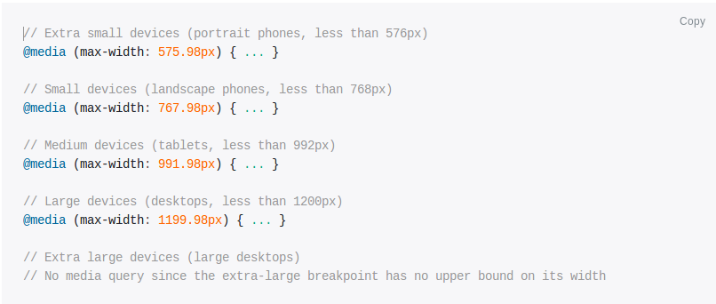

1. **JavaScript & jQuery:** JavaScript is a programming language that adds interactivity to your website (for example: games, responses when buttons are pressed or data entered in forms, dynamic styling, animation). JavaScript is client side Scripting Language that is used to add interactivity to the pages, like on occurrence of particular events(click, scroll, hover etc) calling a function bound with that element.

While jQuery is a fast, small, and feature-rich JavaScript library. It makes things like HTML document traversal and manipulation, event handling, animation, and Ajax much simpler with an easy-to-use API that works across a multitude of browsers. With a combination of versatility and extensibility, jQuery has changed the way that millions of people write JavaScript.

Both JavaScript and jQuery works and access the html elements on the basis of Document Object Model (DOM) model. The Document Object Model (DOM) is a cross-platform and language-independent application programming interface that treats a HTML, XHTML, or XML document as a tree structure wherein each node is an object representing a part of the document.

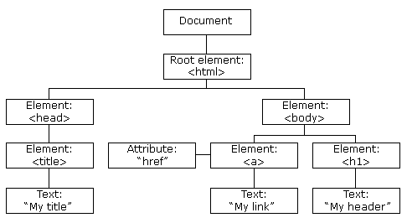

**5. Bootstrap:** Bootstrap is an open source toolkit for developing with HTML, CSS, and JS. Quickly prototype your ideas or build your entire app with our Sass variables and mixins, responsive grid system, extensive prebuilt components, and powerful plugins built on jQuery.It simplify the task of building responsive Websites or Web applications as it contain predefined classes that render the elements in the browser according to the classes applied to that element. Bootstrap uses Grid System:

Bootstrap's grid system allows up to 12 columns across the page. If you do not want to use all 12 columns individually, you can group the columns together to create wider columns:

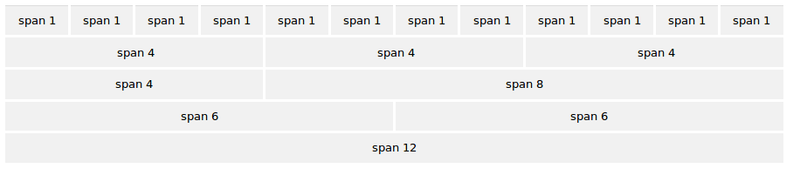

**Why Use Bootstrap?**

**Advantages of Bootstrap:**

* **Easy to use:** Anybody with just basic knowledge of HTML and CSS can start using Bootstrap
* **Responsive features:** Bootstrap's responsive CSS adjusts to phones, tablets, and desktops.
* **Mobile-first approach**: In Bootstrap 3, mobile-first styles are part of the core framework
* **Browser compatibility**: Bootstrap is compatible with all modern browsers (Chrome, Firefox, Internet Explorer, Safari, and Opera)

1. **PHP:** Since We used JavaScript and jQuery to provide interactivity and various vent based actions like form handling, or flipping back of card. But it is not secure to use client side Scripting Language, to deal with the database. Since it might allow hackers to hack the data easily. So we used PHP (Pre Hyper-Text Processor) to deals with the database). It Provides a secure method to interact with the database as it is only executed at the server ends instead of downloading at Client end Desktop.

PHP is a server-side scripting language designed for web development but also used as a general-purpose programming language. Originally created by Rasmus Lerdorf in 1994, the PHP reference implementation is now produced by The PHP Group. Generally PHP known as hypertext preprocessor but earlier it was called Personal Home Page.

PHP is an interpreted language, i.e. there is no need for compilation. PHP is faster than other scripting language. Like Jsp Asp.

 It is used to develop web applications (an application i.e. executed at server side and generates dynamic page).

**PHP Features:**

**Performance:** Script written in PHP executes much faster then those scripts written in other languages such as JSP & ASP.

**Open Source Software:** PHP source code is free available on the web, you can developed all the version of PHP according to your requirement without paying any cost.

**Platform Independent:** PHP are available for WINDOWS, MAC, LINUX & UNIX operating system. A PHP application developed in one OS can be easily executed in other OS also.

**Compatibility:** PHP is compatible with almost all local servers used today like Apache, IIS etc.

**Embedded:** PHP code can be easily embedded within HTML tags and script.

1. **MySQli:** MySQLi is a fast, easy-to-use RDBMS being used for many small and big businesses. MySQLi Extension is developed, marketed, and supported by MySQL. MySQL is becoming so popular because of many good reasons −
   1. MySQLi is released under an open-source license. So you have nothing to pay to use it.
   2. MySQLi is a very powerful program in its own right. It handles a large subset of the functionality of the most expensive and powerful database packages.
   3. MySQLi uses a standard form of the well-known SQL data language.
   4. MySQLi works on many operating systems and with many languages including PHP, PERL, C, C++, JAVA, etc.
   5. MySQLi works very quickly and works well even with large data sets.
   6. MySQLi is very friendly to PHP, the most appreciated language for web development.
   7. MySQLi supports large databases, up to 50 million rows or more in a table. The default file size limit for a table is 4GB, but you can increase this (if your operating system can handle it) to a theoretical limit of 8 million terabytes (TB).
   8. MySQLi is customizable. The open-source GPL license allows programmers to modify the MySQL software to fit their own specific environments.
2. **Apache Rewrite module**: Apache is the most widely used web server software. Developed and maintained by Apache Software Foundation, Apache is an open source software available for free. It runs on 67% of all webservers in the world. It is fast, reliable, and secure. It can be highly customized to meet the needs of many different environments by using extensions and modules. Since the UCIC have apcahe web servers so we are required to use the Apache rewrite module to alter the url

**mod_rewrite**

The mod_rewrite module uses a rule-based rewriting engine, based on a PCRE(Parsing Core Regular Expression) regular-expression parser, to rewrite requested URLs on the fly. By default, mod_rewrite maps a URL to a filesystem path. However, it can also be used to redirect one URL to another URL, or to invoke an internal proxy fetch.

mod_rewrite provides a flexible and powerful way to manipulate URLs using an unlimited number of rules. Each rule can have an unlimited number of attached rule conditions, to allow you to rewrite URL based on server variables, environment variables, HTTP headers, or time stamps.

mod_rewrite operates on the full URL path, including the path-info section. A rewrite rule can be invoked in httpd.conf or in .htaccess. The path generated by a rewrite rule can include a query string, or can lead to internal sub-processing, external request redirection, or internal proxy throughput.

1. **Google Charts and Google Maps API**: Google Charts provides a perfect way to visualize data on your website. The most common way to use Google Charts is with simple JavaScript that you embed in your web page. You load some Google Chart libraries, list the data to be charted, select options to customize your chart, and finally create a chart object with an id that you choose. Then, later in the web page, you create a <div> with that id to display the Google Chart.

Similarly Google provides solution to the Solution of embedding maps to the Websites and Apps with the help of JavaScript Library and Files. For each Google API user needs to Register an API key which can be registered at Google API Console <https://console.developers.google.com/apis>

# 3.Methodology and Coding from various files

All the pages are developed and saved as PHP files, as PHP allows us to use of MVC. It allows us to store the snippet of code that will be repeated in all files without any change, **like the code of the footer, the code of the menu.** And latter include that files with the statement

<?PHP include ‘filename_to_be_included.php’;?>

At right position in the main file. Some files codes are given below

**Index.php**

<!DOCTYPE html>

<!--[if IE 8 ]><html class="ie ie8" class="no-js" lang="en"> <![endif]-->

<!--[if (gte IE 9)|!(IE)]><!-->

<html class="no-js" lang="en">

<head>

<meta name = "keyword" content = "GJUST,Gjus&T,Training&nbsp;and&nbsp;Placement&nbsp;Cell,T&p&nbsp;Cell,T,Partap&nbsp;Singh&nbsp;Malik,Prof.&nbsp;Tankeshwar&nbsp;Kumar,Guru&nbsp;Jambheshwar&nbsp;University&nbsp;of&nbsp;Science&nbsp;&&nbsp;Technology,Rahul&nbsp;Chanana,Gaurav&nbsp;Raheja,Narender&nbsp;Singh,Kartik&nbsp;Goyal">

<meta name = "description" content = "Training &amp; Placement Cell,Guru Jhambheshwar University of Science &amp; Technology">

<meta content="text/html; charset=UTF-8" http-equiv="content-type">

<meta http-equiv="X-UA-Compatible" content="IE=edge">

<meta name="viewport" content="width=device-width, initial-scale=1, maximum-scale=1">

<title>HOME:T&amp;P CELL,GJUS&amp;T

</title>

<!-- favicon start -->

<link rel="shortcut icon" type="image/x-icon" href="images/favicon.ico">

<!-- favicon end -->

<script src="js/main.js" defer></script>

<link rel="stylesheet" href="css/bootstrap.min.css">

<link rel="stylesheet" href="css/style.css">

<link rel="stylesheet" type="text/css" href="css/style.css" media="screen" data-name="skins">

<link href="css/fractionslider.css" rel="stylesheet">

<link href="css/style-fraction.css" rel="stylesheet">

<!-- HTML5 Shim and Respond.js IE8 support of HTML5 elements and media queries -->

<!-- WARNING: Respond.js doesn't work if you view the page via file:// -->

<!--[if lt IE 9]>

<script src="https://oss.maxcdn.com/html5shiv/3.7.2/html5shiv.min.js"></script> <script src="https://oss.maxcdn.com/respond/1.4.2/respond.min.js"></script> <![endif]-->

<!-- time -->

</head>

<body>

<section class="wrapper">

<!--Start Header-->

<header id="header" class="clearfix">

<?php include'header.php';?>

<!-- Navigation

================================================== -->

<div class="navbar navbar-default navbar-static-top" role="navigation">

<?php include'menu.php';?>

<!--/.container --> </div>

</header>

<!--End Header-->

<section class="wrapper">

<section class="page_head">

<div class="container">

<div class="row">

<div class="col-lg-12 col-md-12 col-sm-12">

<h2>GJUS&amp;T T&amp;P Cell</h2>

<nav id="breadcrumbs">

<ul>

<li>You are here:</li>

<li>Home</li>

</ul>

</nav>

</div>

</div>

</div>

</section>

<!--start wrapper-->

<section class="container">

<?php include'slider.php';?>

<div> <marquee direction="left">

<h2>WELCOME&nbsp;TO&nbsp;TRAINING&nbsp;AND&nbsp;PLACEMENT&nbsp;CELL,GJUS&amp;T,HISAR

</h2> </marquee> </div>

<!--start info service-->

<section class="info_service">

<div class="container">

<div class="row sub_content">

<div class="rs_box">

<div class="col-sm-4 col-md-4 col-lg-4">

<div class="serviceBox_1">

<div class="icon_service"> <i class="fa fa-laptop"></i>

<h3>Announcements</h3>

</div>

<div class="fr_content anc"> <marquee direction="up" behavior="scroll"

scrollamount="3" onmouseover="this.stop();" onmouseout="this.start();"

align="middle" height="86%">

<ul style="list-style-type:none; padding:0">

<?php

require('config.php');

include('visitorcounter.php');

$dateser = date("y-m-d");

$query1 = "select postdata,link from post where postdate>='$dateser' order by postdate desc limit 5";

$res1 = mysqli_query($connection,$query1);

$count1 = mysqli_num_rows($res1);

while($row1 = mysqli_fetch_assoc($res1)){

$link = $row1['link'];

if($link!='' and $link!='#'){

$printlink = "<a href='$link'>(Click here for more details)</a>"; }

else{

$printlink = ""; }

echo "<li><strong><p class='nbinfo' onmouseup='stop'>".$row1['postdata']."<img src='images/new-y.gif'></strong><br>".$printlink."</p></li>";

}

$x = 5;

if($count1<=$x){

$target = $x-$count1;

$query3 ="select postdata,link from post where postdate<'$dateser' order by postdate desc limit $target ";

$res3 = mysqli_query($connection,$query3);

while($row3=mysqli_fetch_assoc($res3)){

$link1 = $row3['link'];

if($link1!='' and $link1!='#'){

$printlink4 = "<a href='$link'>(Click here for more details)</a>"; }

else{

$printlink4 = ""; }

echo "<li><strong><p class='nbinfo' onmouseup='stop'>".$row3['postdata']."</strong><br>".$printlink4."</p></li>";

}

}

?>

</ul>

</marquee> </div>

<br>

<a class="read" href="t&w.php">Read more</a> </div>

</div>

<!--*******************>

<**********POPUP********>

***********************-->

<div id="myModal" class="modal fade" role="dialog">

<div class="modal-dialog">

<!-- Modal content-->

<div class="modal-content">

<div class="modal-header">

<button type="button" class="close" data-dismiss="modal">&times;</button>

<h4 class="modal-title">Notifications</h4>

</div>

<?php

$res2 = mysqli_query($connection,$query1);

while($row2 = mysqli_fetch_assoc($res2)){

$link = $row2['link'];

if($link!='' and $link!='#'){

$printlink2 = "<a href='$link'>(Click here for more details)</a>"; }

else{

$printlink2 = ""; }

echo "<div class='modal-body'><p class='nbinfo'>".$row2['postdata'].$printlink2."<img src='images/new-y.gif'></p></div>";

}

$res4 = mysqli_query($connection,$query3);

while($row4 = mysqli_fetch_assoc($res4)){

$link2 = $row4['link'];

if($link2!='' and $link2!='#'){

$printlink3 = "<a href='$link'>(Click here for more details)</a>"; }

else{

$printlink3 = ""; }

echo "<div class='modal-body'><p class='nbinfo'>".$row4['postdata'].$printlink3."</p></div>";

}

?>

<div class="modal-footer">

<button type="button" class="btn btn-default" data-dismiss="modal">Close</button>

</div>

</div>

</div>

</div>

<!--**************>

<***Popup end*****>

<***************-->

<div class="col-sm-4 col-md-4 col-lg-4">

<div class="serviceBox_1">

<div class="icon_service"> <i class="fa fa-envelope-o"></i>

<h3>VC Message</h3>

</div>

<div class="fr_content"> <img src="images/VC.jpg" style="float:left;margin-right:20px; ">

<p align="justify">I have the pleasure to welcome you to

this State Technical University of Haryana, Which was

established in 1995 and has the honour of having been

thrice accredited ‘A’ Grade by National Assessment

&amp; Accreditation Council. Recently The University

has been chosen as one of the few universities of the

country for Global Initiative for Academic

Network(GIAN) and has secured 24th rank amongst all

Universities/Institutions in India. This ranking has

been done by National Institutional Ranking

Framework(NIRF), Ministry of Human Resource Development, Government of India, New Delhi in 2016. </p>

<a class="read" href="vision_mission#vc">Read more</a>

</div>

</div>

</div>

<div class="col-sm-4 col-md-4 col-lg-4">

<div class="serviceBox_1">

<div class="icon_service"> <i class="fa fa-envelope-o"></i>

<h3>Director Message</h3>

</div>

<div class="fr_content"> <img src="images/director.jpg" style="float:left;margin-right:20px;">

<p align="justify">Our University is one of the fastest

growing Technical Universities of India achieving such

high rankings in last two decades. In last 21 years

since its inception, University has produced more than

15k bright professionals currently working in top

organisations in India as well as abroad. Due to

having Industry Experience of more than 14 Years, I

personally believe that for meeting the time bound

targets in qualitative manner, Industries require

students having excellent learning capacity,

conceptual clarity of subjects, creative mindset and

exposure to new technologies. </p>

<a class="read" href="vision_mission#dtpc">Read

more</a> </div>

</div>

</div>

</div>

</div>

</div>

</section>

<!--end info service-->

<!--Start recent work-->

<section class="latest_work">

<div class="container">

<div class="row sub_content">

<div class="carousel-intro">

<div class="col-md-12">

<div class="dividerHeading">

<h4><span>Recent Work</span></h4>

</div>

<div class="carousel-navi">

<div id="work-prev" class="arrow-left jcarousel-prev"><i class="fa fa-angle-left"></i></div>

<div id="work-next" class="arrow-right jcarousel-next"><i

class="fa fa-angle-right"></i></div>

</div>

<div class="clearfix"></div>

</div>

</div>

<div class="jcarousel recent-work-jc">

<ul class="jcarousel-list">

<!-- Recent Work Item -->

<li class="col-sm-3 col-md-3 col-lg-3">

<div class="recent-item">

<figure>

<div class="touching medium"> <img src="images/recentworks/portfolio_1.jpg"

alt=""> </div>

<div class="option"> <a href="images/recentworks/portfolio_1.jpg"

class="hover-zoom mfp-image"><i class="fa fa-search"></i></a>

</div>

<figcaption class="item-description">

<h5>Workshop</h5>

</figcaption> </figure>

</div>

</li>

<!-- Recent Work Item -->

<li class="col-sm-3 col-md-3 col-lg-3">

<div class="recent-item">

<figure>

<div class="touching medium"> <img src="images/recentworks/portfolio_2.jpg"

alt=""> </div>

<div class="option"> <a href="images/recentworks/portfolio_2.jpg"

class="hover-zoom mfp-image"><i class="fa fa-search"></i></a>

</div>

<figcaption class="item-description">

<h5>Workshop</h5>

</figcaption> </figcaption> </figure>

</div>

</li>

<!-- Recent Work Item -->

<li class="col-sm-3 col-md-3 col-lg-3">

<div class="recent-item">

<figure>

<div class="touching medium"> <img src="images/recentworks/portfolio_3.jpg"

alt=""> </div>

<div class="option"> <a href="images/recentworks/portfolio_3.jpg"

class="hover-zoom mfp-image"><i class="fa fa-search"></i></a>

</div>

<figcaption class="item-description">

<h5>Workshop</h5>

</figcaption> </figcaption> </figure>

</div>

</li>

<!-- Recent Work Item -->

<li class="col-sm-3 col-md-3 col-lg-3">

<div class="recent-item">

<figure>

<div class="touching medium"> <img src="images/recentworks/portfolio_4.jpg"

alt=""> </div>

<div class="option"> <a href="images/recentworks/portfolio_4.jpg"

class="hover-zoom mfp-image"><i class="fa fa-search"></i></a>

</div>

<figcaption class="item-description">

<h5>Workshop</h5>

</figcaption> </figure>

</div>

</li>

<!-- Recent Work Item -->

<li class="col-sm-3 col-md-3 col-lg-3">

<div class="recent-item">

<figure>

<div class="touching medium"> <img src="images/recentworks/portfolio_5.jpg"

alt=""> </div>

<div class="option"> <a href="images/recentworks/portfolio_5.jpg"

class="hover-zoom mfp-image"><i class="fa fa-search"></i></a>

</div>

<figcaption class="item-description">

<h5>Workshop</h5>

</figcaption> </figure>

</div>

</li>

<!-- Recent Work Item -->

<li class="col-sm-3 col-md-3 col-lg-3">

<div class="recent-item">

<figure>

<div class="touching medium"> <img src="images/recentworks/portfolio_6.jpg"

alt=""> </div>

<div class="option"> <a href="images/recentworks/portfolio_6.jpg"

class="hover-zoom mfp-image"><i class="fa fa-search"></i></a> </div>

<figcaption class="item-description">

<h5>Workshop</h5>

</figcaption> </figure>

</div>

</li>

<!-- Recent Work Item -->

<li class="col-sm-3 col-md-3 col-lg-3">

<div class="recent-item">

<figure>

<div class="touching medium"> <img src="images/recentworks/portfolio_7.jpg"

alt=""> </div>

<div class="option"> <a href="images/recentworks/portfolio_7.jpg"

class="hover-zoom mfp-image"><i class="fa fa-search"></i></a>

</div>

<figcaption class="item-description">

<h5>Workshop</h5>

</figcaption> </figure>

</div>

</li>

<!-- Recent Work Item -->

<li class="col-sm-3 col-md-3 col-lg-3">

<div class="recent-item">

<figure>

<div class="touching medium"> <img src="images/recentworks/portfolio_8.jpg"

alt=""> </div>

<div class="option"> <a href="images/recentworks/portfolio_8.jpg"

class="hover-zoom mfp-image"><i class="fa fa-search"></i></a>

</div>

<figcaption class="item-description">

<h5>Workshop</h5>

</figcaption> </figure>

</div>

</li>

</ul>

</div>

</div>

</div>

</section>

<!--Start recent work-->

<section class="clients">

<div class="container">

<div class="row sub_content">

<div class="col-lg-12 col-md-12 col-sm-12">

<div class="dividerHeading">

<h4><span>Past Recruiters</span></h4>

</div>

<div class="our_clients"> <marquee> <a href="past_recruiters.php"

data-placement="bottom" data-toggle="tooltip"><img src="images/past-recruiters/hartron.jpg"

alt=""></a> &nbsp; &nbsp; &nbsp; &nbsp; <a href="" past_recruiters.php=""

data-placement="bottom" data-toggle="tooltip"><img src="images/past-recruiters/ibm.jpg"

alt=""></a>&nbsp; &nbsp;&nbsp; &nbsp;&nbsp; &nbsp;

&nbsp; <a href="past_recruiters.php" data-placement="bottom"

data-toggle="tooltip"><img src="images/past-recruiters/wipro.jpg" alt=""></a>&nbsp;

&nbsp;&nbsp; &nbsp; &nbsp; &nbsp; <a href="past_recruiters.php"

data-placement="bottom" data-toggle="tooltip"><img src="images/past-recruiters/kodak.jpg"

alt=""></a>&nbsp; &nbsp; &nbsp; &nbsp; &nbsp; <a href="past_recruiters.php"

data-placement="bottom" data-toggle="tooltip"><img src="images/past-recruiters/itc.jpg"

alt=""></a>&nbsp; &nbsp; &nbsp; <a href="past_recruiters.php"

data-placement="bottom" data-toggle="tooltip"><img src="images/past-recruiters/darcl.jpg"

alt=""></a> <a href="#" data-placement="bottom" data-toggle="tooltip"><img

src="images/past-recruiters/daffodil.jpg" alt=""></a>&nbsp; &nbsp;

&nbsp; <a href="past_recruiters.php" data-placement="bottom"

data-toggle="tooltip"><img src="images/past-recruiters/expersit.jpg" alt=""></a>&nbsp;

&nbsp; &nbsp; <a href="past_recruiters.php" data-placement="bottom"

data-toggle="tooltip"><img src="images/past-recruiters/alembic.jpg" alt=""></a>&nbsp;

&nbsp; &nbsp; </marquee> </div>

</div>

</div>

</div>

</section>

<!--end wrapper-->

<!--.test-->

<div class = "row">

<div class="col-lg-6 col-xs-12 col-md-6 col-sm-6">

<div class="row">

<div class="dividerHeading">

<h4><span>Login/Signup</span></h4></div>

<div class = "text-center">

<img src="images/coming_soon.gif"> <br/>

<a href="register.php" class = "text-center"><img src="images/sign.jpg"

height="100" width="150"></a>&nbsp;&nbsp;

<a href="#login" class = "text-center"><img src="images/login.jpg" height="100"

width="150"></a>

<a name="login"> </a>

</div>

</div>

<div class="row text-center">

<div class="dividerHeading">

<h4><span>Our Partner</span></h4></div>

<a href="https://play.google.com/store/apps/details?id=com.scholar.engineering.banking.ssc&hl=en" ><img src="images/hellotopper.jpg" height="100"

width="150"></a>

</div>

</div>

<!--./row-->

<div class="col-lg-6 col-xs-12 col-md-6 col-sm-6">

<div class="dividerHeading">

<h4><span>Testimonials</span></h4>

</div>

<div class="testimonial carousel slide" id="testimonial-carousel">

<div class="carousel-inner">

<div class="active item">

<div class="testimonial-item">

<div class="icon"><i class="fa fa-quote-right"></i></div>

<blockquote>

<p class="fr_content">It has always been a pleasure interacting with faculty and students of GJUST, Hisar. Students of GJUST are extra ordinary and have sound knowledge of the subject. They are being further groomed to grow in their career and meet leadership requirements of our organisation. Many of the students have been highly successful and they are being responsible for key positions across organisation. Training and placement cell of university is highly proactive and their efforts to get right placement for their students is highly appreciated. I wish a great luck to Faculty, Students and T&P cell. </p>

</blockquote>

<div class="icon-tr"></div>

<div class="testimonial-review"> <img alt="Manoj Kaushik" src="images/testimonials/manojkaushik.jpg">

<h1>Manoj Kaushik<small>Huhtamaki PPL</small></h1>

</div>

</div>

</div>

<div class="item">

<div class="testimonial-item">

<div class="icon"><i class="fa fa-quote-right"></i></div>

<blockquote>

<p class="fr_content"> Golden time of my life was studying in department of Environmental Science and Engineering GJU S&T, Hisar, Haryana. Collaborative approach

among Faculty and Students resulted into development

of Analytical and like NET, SLET, GATE etc.

I always feel proud to be a part of this Big Family "GJUiets".

</p>

</blockquote>

<div class="icon-tr"></div>

<div class="testimonial-review"> <img alt="Deepak Bansal" src="images/testimonials/deepak.jpg">

<h1>Deepak Bansal<small>AGM, Corp. TQM and ME,JBM Group</small></h1>

</div>

</div>

</div>

<div class="item">

<div class="testimonial-item">

<div class="icon"><i class="fa fa-quote-right"></i></div>

<blockquote>

<p class="fr_content">

GJU being my alma-mater I have seen it evolve from a modest 2 building infrastructure to becoming one of the best campus in India with state of the art facilities and amenities. The evolution has been all around especially in the functioning of Placement Cell which has become very active. Their keen interest in all round development of students especially in soft skills calls for special appreciation. I wish them all the luck and very best in all their future endeavors.

</p>

</blockquote>

<div class="icon-tr"></div>

<div class="testimonial-review"> <img alt="Pankaj Chaudhary" src="images/testimonials/pankaj.jpg">

<h1>Pankaj Chaudhary<small>Director-TIME-Hisar</small></h1>

</div>

</div>

</div>

<div class="item">

<div class="testimonial-item">

<div class="icon"><i class="fa fa-quote-right"></i></div>

<blockquote>

<p class="fr_content">

Passion is what makes an engineer successful one but what matters the most is right education institution which fuels that passion. I have experienced a unique edge as an engineer at GJU, latest techniques, emerging technologies, best infrastructure and faculty which understands individual needs, available all under one umbrella. I stand proud and excited to start my journey as an engineer in one of the good companies.

</p>

</blockquote>

<div class="icon-tr"></div>

<div class="testimonial-review"> <img alt="Mahavir" src="images/testimonials/mahavir.jpg">

<h1>Mahavir<small>Galaxy Offset India pvt. ltd.(Plant Head)</small></h1>

</div>

</div>

</div>

<div class="item">

<div class="testimonial-item">

<div class="icon"><i class="fa fa-quote-right"></i></div>

<blockquote>

<p class="fr_content">

For me getting chance to study at Haryana technical University, Hisar was an important milestone of my life. The department of Food Technology is having state of the art facilities be it Classrooms or research laboratories. Under the guidance of Gurus who are expert of their respective subjects I could develop my knowledge and skills which still helps me in my routine professional life. The faculty and overall ambiance is so open and enriching that I could develop my fundamentals on food science as well as I could groom my personality through various opportunities be it seminars, projects or presentations or industrial trainings. The syllabus and study programs were so relevant that till date I find myself comfortable in understanding any new product or process coming across the shop floor to commercialise it.</p>

</blockquote>

<div class="icon-tr"></div>

<div class="testimonial-review"> <img alt="Santosh Bhakar" src="images/testimonials/santosh.jpg">

<h1>Santosh Bhakar<small>ITC</small></h1>

</div>

</div>

</div>

</div>

<div class="testimonial-buttons"><a data-slide="prev" href="#testimonial-carousel"><i

class="fa fa-chevron-left"></i></a> <a data-slide="next"

href="#testimonial-carousel"><i class="fa fa-chevron-right"></i></a></div>

</div>

</div>

<!-- TESTIMONIALS END --> </div>

</div>

</section>

</section>

<!--./row-->

<!--.test end-->

<!-- Test2-->

<!--Test2 end-->

<!--start footer-->

<footer class="footer">

<?php include'footer.php';?>

</footer>

<!--end footer-->

<section class="footer_bottom">

<?php include'bottom_footer.php';?>

</section>

<script type="text/javascript" src="js/jquery-1.10.2.min.js" ></script>

<script src="js/bootstrap.min.js" ></script>

<script type="text/javascript" src="js/jquery.magnific-popup.min.js" defer></script>

<script type="text/javascript" src="js/jquery.jcarousel.js" defer></script>

<script src="js/jquery.fractionslider.js" type="text/javascript" charset="utf-8" defer></script>

<script type="text/javascript" src="js/jquery.smartmenus.min.js" defer></script>

<script type="text/javascript" src="js/jquery.smartmenus.bootstrap.min.js" defer></script>

<script type="text/javascript" src="js/jquery.isotope.min.js" defer></script>

<script type="text/javascript" src="js/swipe.js" defer></script>

<script type="text/javascript" src="js/jquery-scrolltofixed-min.js" defer></script>

<script src="js/jquery.easing.1.3.js" defer></script>

<script type="text/javascript" src="js/jquery.cookie.js" defer></script>

<script>

$(window).load(function(){

$('.slider').fractionSlider({

'fullWidth': true,

'controls': true,

'responsive': true,

'dimensions': "1920,450",

'increase': true,

'pauseOnHover': true,

'slideEndAnimation': true,

'autoChange': true

});

if(!sessionStorage.getItem('key')){

console.log('hello');

sessionStorage.setItem('key', 1);

$('#myModal').modal('show');

}else{

console.log('test');

}

});

</script>

</section>

</body>

</html>

config.php

<?php

error_reporting(0);

if(session_id()=='') session_start();

$connection = mysqli_connect('localhost','username','password');

if(!$connection)

die(mysqli_error()."database connection failed");

mysqli_select_db($connection,'dbname');

?>

.htaccess

<IfModule mod_rewrite.c>

RewriteEngine On

RewriteCond %{REQUEST_FILENAME} !-f

RewriteRule ^([^\.]+)$ $1.php [NC,L]

</IfModule>

# Screenshot from 2018-01-23 20-36-00lumiaiphone6 4.Testing Samplesiphone se

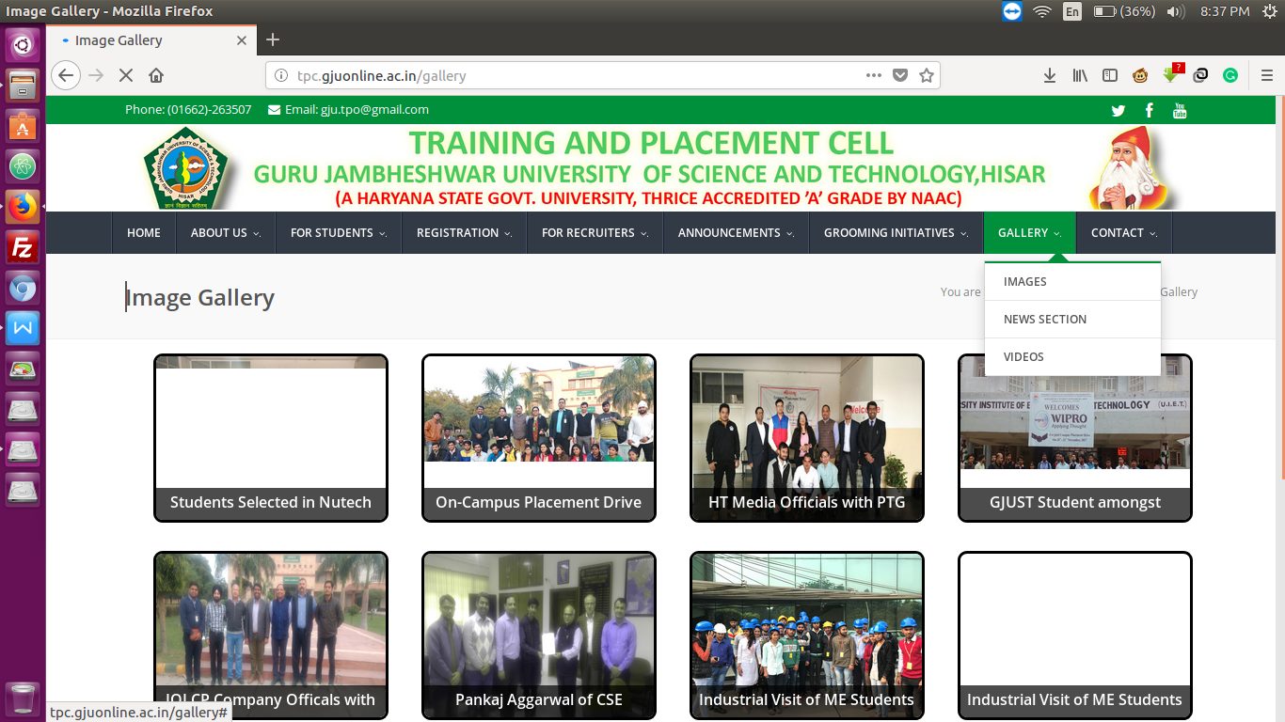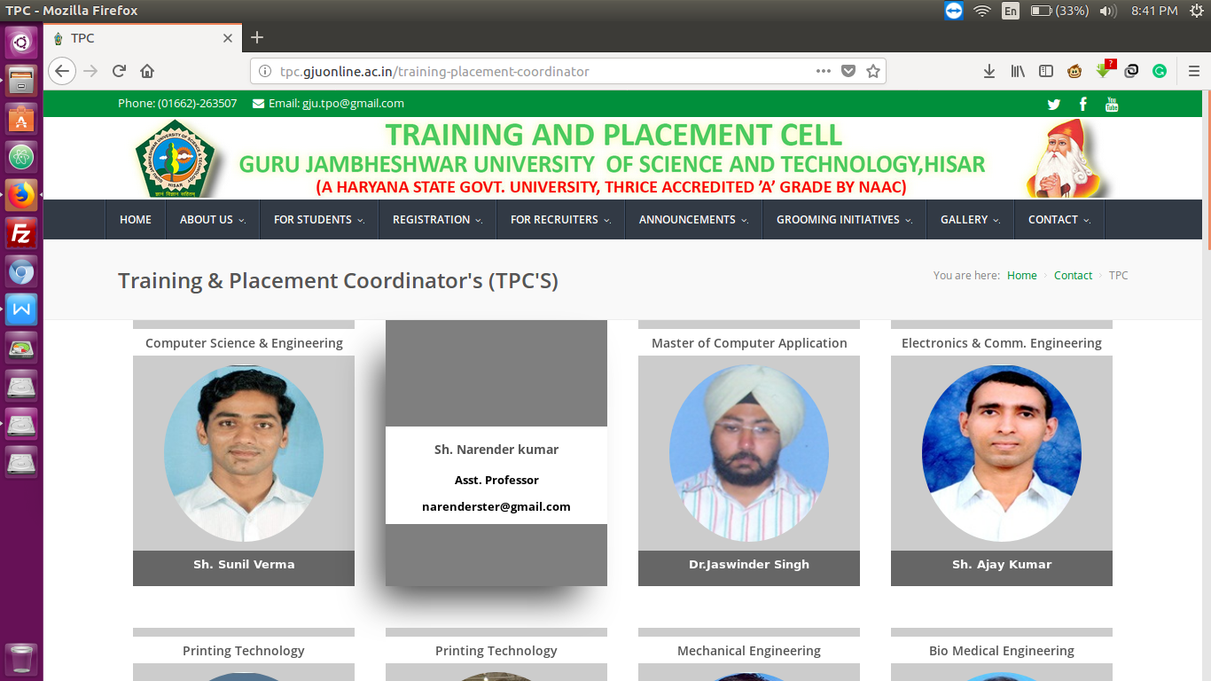

**5.Bibliography**

Reference

* www.w3schools.com
* www.tutorialsPoint.com
* www.stackoverflow.com
* http://httpd.apache.org/docs/current/mod/mod_rewrite.html